

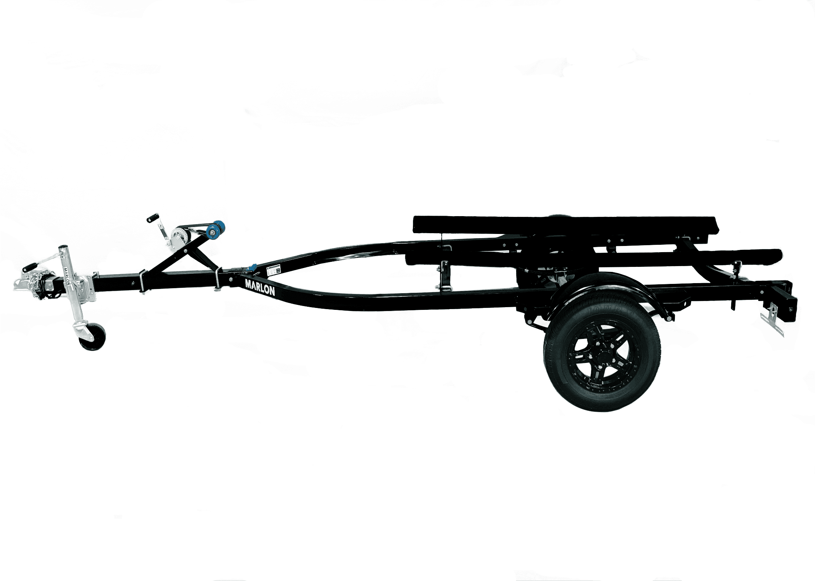

Year: | 2024 |  | Make: | Marlon |  | Model: |  | PWC
Length: | 14.9’ |  | Color: | Black |  | Hours: |  | NEW
Options: | 1500 LB capacity
Trailer: | Single axle Trailer w/ Jack
Stock Number: |  |  |  |  | ID #
Price: |  | $2,700 plus taxes

